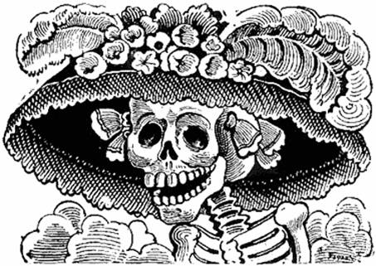

Dear 1st & 2nd grade students and parents,

In art class we are studying the cultural practice of el día de los muertos, or the Day of the Dead. This celebration occurs from November 1-2 throughout Latin America and we are focusing on how this festive time is specifically celebrated in Mexico. Students are currently creating artwork such as skeleton drawings, sugar skull sculptures, papel picado, paper flowers and monarch butterflies which all carry great significance for this cultural tradition. The children’s artwork will be placed in our art installation in the gallery spaces of the art studios.

We would like to extend an invitation to our primary school art students and their families to further participate in our Day of the Dead ofrenda by bringing in a photograph(s) of loved family members, friends and/or important historical figures who have passed. We will honor their important place in our lives by their images as we collect them for display on our ofrenda. If you'd like to bring in an image of a family member, friend, or any cultural icon who is important to you, please do so. The image may be a xerox of an actual photograph (color or black & white), or even a framed picture. Framed images are wonderful, however please leave extremely valuable frames/pictures at home. All photographs will be returned.

Also, write your child’s name, room number/teacher on the back of the image, alongside the name of the person being honored (any written description about the person is very welcome). We, Mrs. Mazurek and Ms. Romero, will be collecting images on an ongoing basis, and they will be returned beginning the week of November 23, when the ofrenda is disassembled. Photographs may be dropped off in the morning in either room 233 or 212. Below is a link to general information about the celebration. And thank you for your kind participation and support.

Sincerely,

Ms. Romero & Mrs. Mazurek

http://www.art-is-fun.com/day-of-the-dead-facts#who

http://latino.si.edu/dayofthedead/

